SHELL SCRIPTS

1) Swap two numbers without using third

variable

SHELL SCRIPTS ASSIGNMENT

1) Swap two numbers without using a third variable

Code:

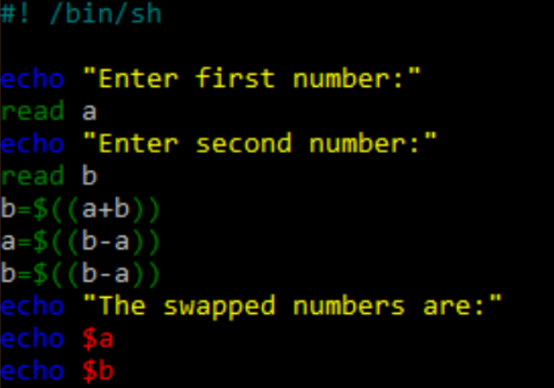

Output:

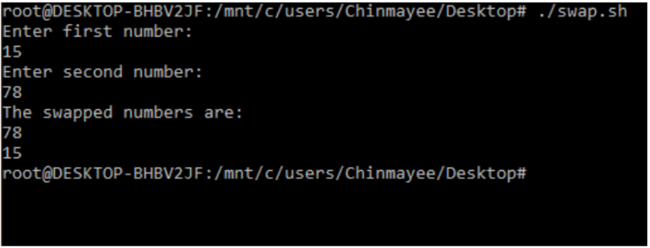

2) Find the sum of first ‘N’ numbers in Fibonacci Series

Code:

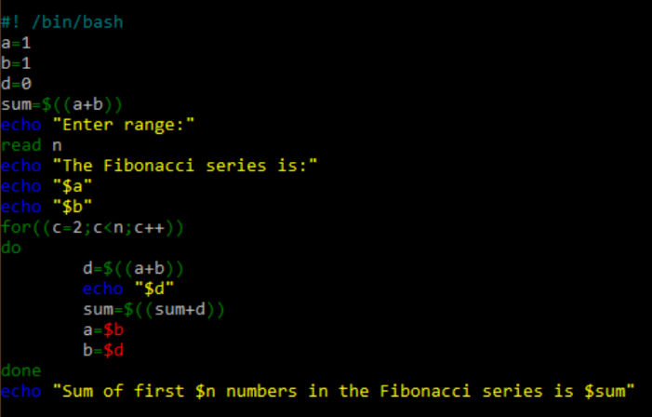

Output:

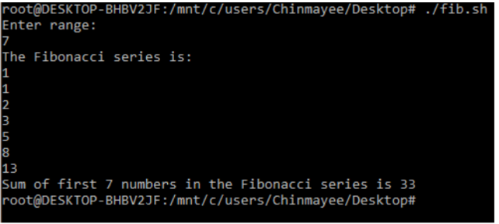

3) Print a given number in reverse order and

sum of the individual digits

Code:

3) Print a given number in reverse order and the sum of the individual digits

Code:

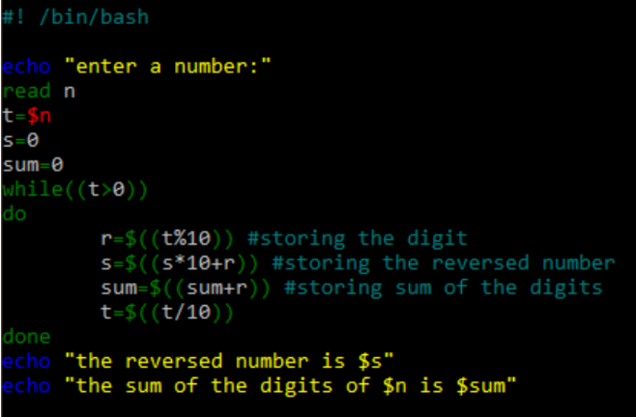

Output:

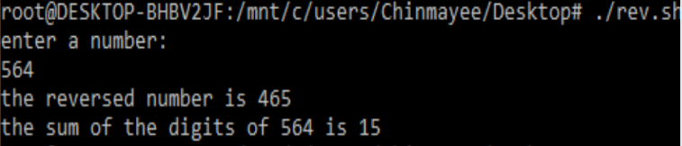

4) Read two strings and display whether it is

equal , not equal, null strings or string with

special characters

Code:

4) Read two strings and display whether it is equal not equal, null strings, or string with special characters

Code:

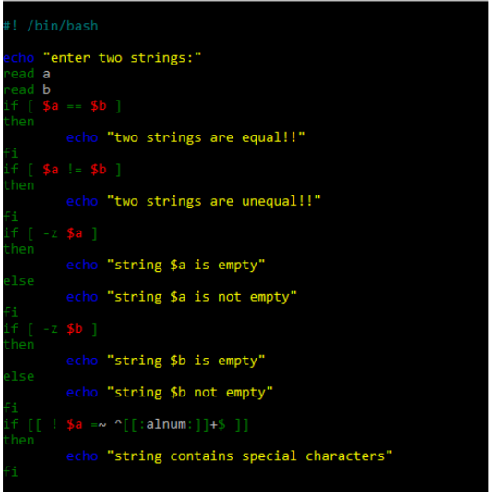

Output:

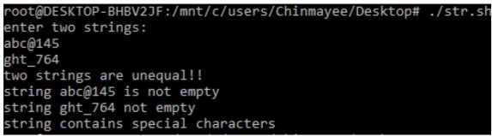

5) Accept one integer argument and print its multiplication table

Code:

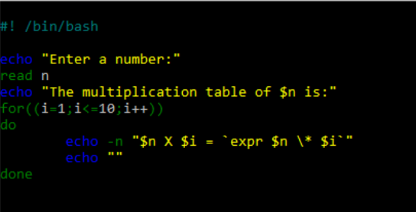

Output:

